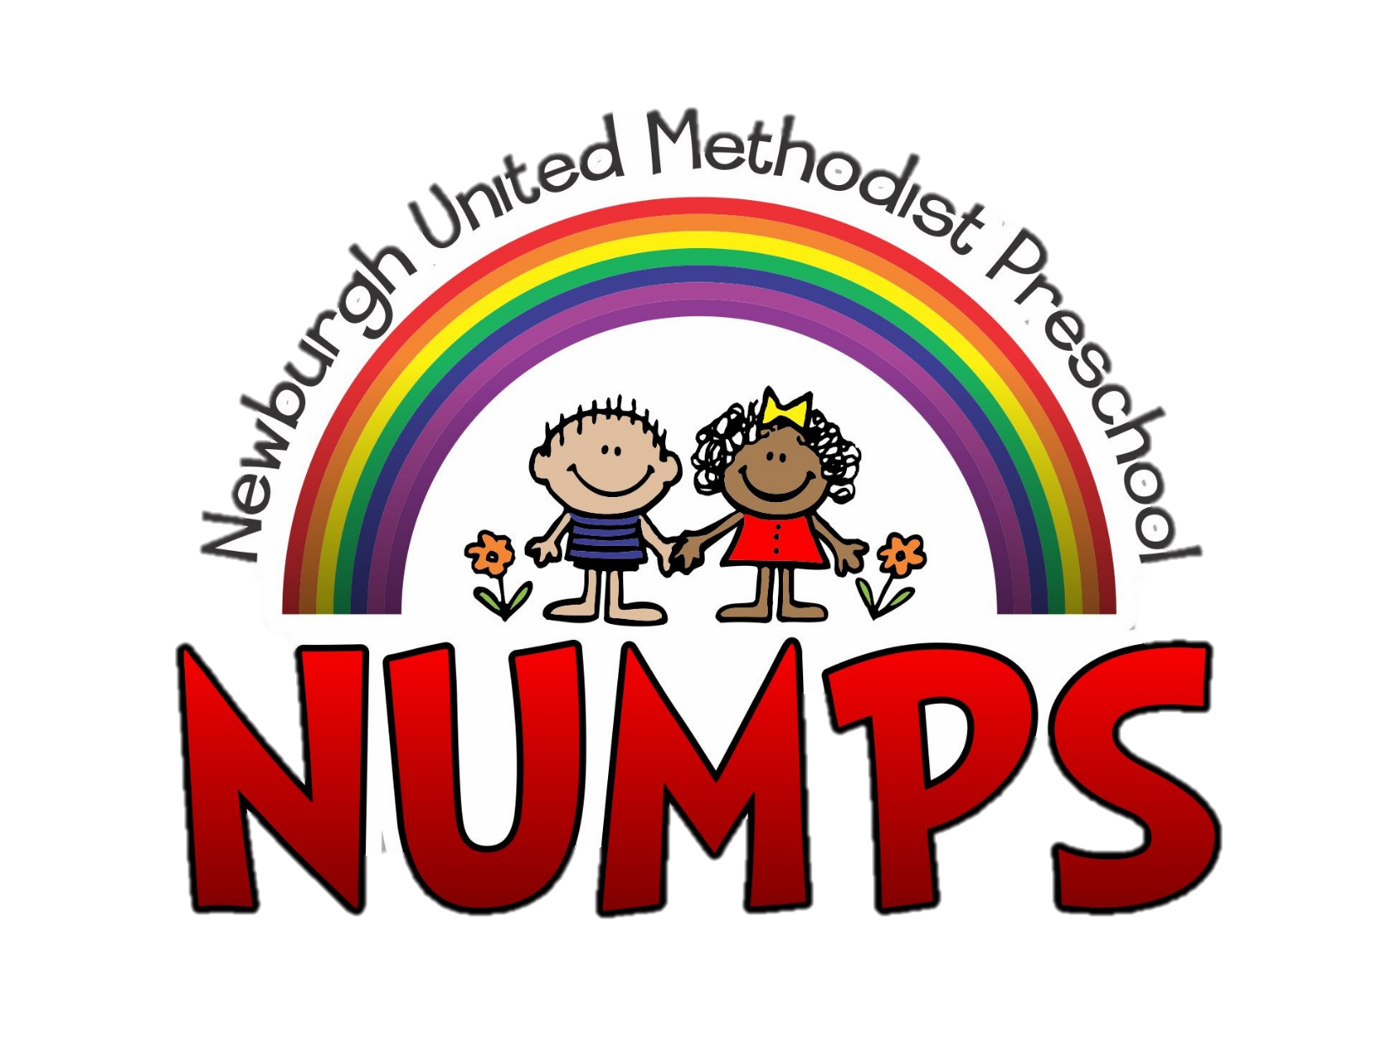
PARENT HANDBOOK

Older 3’s and Pre-K
2022-2023 School Year

address: 4178 SR 261 ᷺ Newburgh IN 47630
website: https://www.numps.org/
phone: (812) 853-6261
email: numpsdirector@gmail.com Scan here with your
office hours: 8:30 a.m. – 3:00 p.m. Monday – Friday. phone for an electronic
copy of the handbook

Table of Contents
Mission of NUMPS 3
Absences 3
Allergies 4
Arrival and Dismissal Procedures 4
Arrival 4
Dismissal 5
Birthday Celebrations including Classroom Parties 5
Discipline Guidelines 5
Classroom Calendars 7
Clothing & Shoes 7
Early and Late Pick Up 7
Facebook 7
Field Trips 7
Fundraisers including Scholastic Books 7
Make Up Days 8
Medical Emergencies and Accidental Injury 8
Medication 8
Missions and Community Service 8
Parent Volunteers 8
Progress Reports 9
Safety 9
School Bags (no Backpacks) and What to Bring in Them 9
Snacks (no drinks) 9
Lunch Bunch 10
Staff Contact Information 10
Student Information including Legal Matters 11
Tuition 11
Weather 11

Mission of NUMPS
The Newburgh United Methodist Preschool (NUMPS) program is an outreach ministry for the Newburgh United Methodist Church. It is a child-centered school, which provides opportunities in a happy Christian environment for children to grow intellectually, socially, emotionally, physically and spiritually. Children will experience a warm accepting atmosphere as they interact with adults and other children. Learning experiences will be focused within both play-oriented and teacher-directed situations.
The goals of the Newburgh United Methodist Preschool (NUMPS) are:
- To develop in the child a sense of self-worth and well-being
- To help the child become accustomed to a varied social environment
- To provide concrete play experiences – one in which they can test out their own ideas, solve problems and express their own creativity
- To provide opportunities for open free choices under the teacher’s guidance
- To provide a variety of instruction with “hands on” material to promote conceptual thinking
- To develop large and small muscle coordination
- To develop a Christian atmosphere in which to work and play
The Preschool Team
The Newburgh United Methodist Preschool (NUMPS) program is under the administration of the Newburgh United Methodist Preschool Team. The Preschool Team meets on a regular basis and acts as a liaison between the Preschool and the other working committees of the Newburgh United Methodist Church.
Members of the Preschool Team
Jacque | Barnette | jacquelinekeneipp@hotmail.com | Co-Chair
Rachel | Begle | rachelbegle@gmail.com | Member
Laura | Hatfield | lehatfield@gmail.com | Member
Alicia | Hawa | aliciahawa@gmail.com | Member
Lisa | Hornung | lhornung1@yahoo.com | Assistant Director
Sandy | Minasian | numpsdirector@gmail.com | Preschool Director
Janine | Moore | janine3raven@gmail.com | Co-Chair
Denee | Riley | denee.riley1128@gmail.com | Communications Assistant
Kara | Sergesketter | dkserg@yahoo.com | Member
Katie | Taylor | kbug25@yahoo.com | Member
Laura | Tutt | lmatutt@yahoo.com | Financial Assistant

Absences
Please notify the preschool office (call: (812) 853-6261 or email: numpsdirector@gmail.com ) when your child will not be attending school.
Help us protect our children by keeping your child home if any of these conditions exist:
- A fever: your child must be fever free for at least 24 hours prior to returning to school. This is fever free without symptoms or medication!
- Heavy nasal congestion: your child should not attend school if they have thick, discolored (green) discharge coming from their nose.
- Frequent, heavy or constant cough
- Vomiting/Diarrhea: must be symptom free for at least 24 hours to return to school
- Lice: your child must be nit and active lice free to return to school
- Unexplained rash
- Fussy, cranky or unusual behavior
- Other symptoms which include but are not limited to: red eyes, severe sore throat, headache, abdominal pain, loose stools, impetigo, hand/ foot mouth disease, chicken pox, fifth’s disease, flu like symptoms.

Allergies
While we strive to keep the classrooms free of products containing nuts (including peanuts), due to the high usage of this building for church activities and by other community groups, this building like any other public building should never be considered 100% nut free.

Arrival and Dismissal Procedures

Arrival
Children should arrive between 8:50-9:00 a.m. or 12:20-12:30 p.m.
Classes begin at 9:00am, 12:30pm
ALL students must be dropped off through the carpool line.
Students will be greeted at Door # 1 by the NUMPS staff and helped from the vehicle. During arrival times, teachers will be in the classroom doorways to monitor the children in the hallway as well as in the classroom.
If you have a Young 2s & 3s student AND a preschool student, you can bring in your preschool student with your Young 2s & 3s student. For Young 2s and 3s: Arrival is from 8:45-9:00. Park in the parking lot outside Door # 2, handicap spots are okay to use. Enter through Door # 2, turn left and walk down the hall to the check-in counter. The teacher will receive your child and take them to their room. Your preschool student will wait near the check-in counter in a designated area under adult supervision.
Indiana State Law requires: Children between the ages of 4 and 7 are required to sit in booster seats and be restrained by both lap and shoulder belts. Children 3 and under should be restrained in a car seat that meets the requirements of the child’s age, height and weight.
Car Seats
Indiana State Law requires: Children between the ages of 4 and 7 are required to sit in booster seats and be restrained by both lap and shoulder belts. Children 3 and under should be restrained in a car seat that meets the requirements of the child’s age, height and weight.

Dismissal
Dismissal for the morning session begins at 11:15 and ends at 11:30. Dismissal for the afternoon session begins at 2:45 and ends at 3:00. EVERYONE will use the carpool line. Please display your car tag from the rearview mirror. A teacher will bring your child to the vehicle. They will be loaded on the passenger side only! No exceptions. To keep the line moving and avoid back up, RIGHT-HAND TURNS only out of the parking lot. ahead.
If someone other than the regular pick-up person comes to pick up your child, we reserve the right to ask for identification prior to releasing your child to them. This includes the child’s parents if they do not pick up on a regular basis. Please do not take offense to this policy. This is for your child’s safety.
If you have a Young 2s & 3s student AND a preschool student, you can pick up your preschool student with your Young 2s & 3s student. Young 2s & 3s dismissal begins at 11:15 and ends at 11:30. Park in the parking lot outside Door # 2. Enter through Door # 2, and wait at the check-in counter. Use the crosswalk upon exiting. Watch for traffic as the carline will be active for preschool dismissal at this time. Carefully merge into the car line and out to the highway. RIGHT HAND TURNS only out of the parking lot.

Birthday Celebrations including Classroom Parties
Each child will have the opportunity to celebrate their birthday (or un-birthday) at school. You may provide a special snack on this special day. Birthday Treat Ideas – Cookie Cakes, Ice Cream Cups, Brownies, Fruit kabobs, snack mix. You may bring special napkins, plates and cups. NO CUPCAKES, Please. We will be happy to send home party invitations in your child’s classmate’s bags as long as they include the entire class. Please, no exclusions.
At the teacher’s discretion, on the day your child is to celebrate their birthday with the class they may be asked to bring a show and tell item to share. This is considered to be a special and important part of your child’s time at school. Guns, swords, and other toys which promote extreme physical play and/or violence are not allowed at school especially as show and tell items.
Classroom Parties : Parties will be held for Fall Celebration/Halloween and Easter. Parents will have the opportunity to sign up to help plan, organize and execute these special days.

Discipline Guidelines
School Wide Rules for Behavior: All the Preschool classrooms will establish these rules for the school year. These are rules students will be asked to follow all through their lives. We ask that you encourage your child to follow these rules. Your support is appreciated.
The teachers will discuss expectations early in the year. The following rules and consequences will be explained thoroughly.
- Always tell the truth
- Keep your hands to yourself in the classroom and hallways.
- Clean up your area when you have completed your work, snack and play.
- Sit quietly when the teacher or others are speaking.
- Respect others all the time.
- Straight, quiet line in the hallway.
- Do my best when I do my school work.
- Bathroom conduct – no playing, flush the toilet, wash hands in the classroom, do not play with towels/soap.
The Newburgh United Methodist Preschool Committee believes that discipline is a required condition for educating, teaching and learning. This means that students, parents, teachers and staff members must share the responsibility to ensure that discipline pervades the entire school environment. The information found here is a mere general guideline. NUMPS will take specific action in each particular case and in consideration of each set of circumstances.
While positive reinforcement for good student behavior is encouraged and rewarded, consequences will be implemented when students choose to engage in behavior, which is outside the normal developmental limits of social/emotional behaviors. These consequences are in place to ensure the health and safety of the child, other students, teachers and staff of the program. Consequences will be imposed for student misconduct, which occurs during school hours, during or when traveling to and from school sponsored or related activities.
Usually, disciplinary incidents will be supported with written documentation. Below is the exemplary list of consequences, which is not limited to be an all-inclusive list. NUMPS may address any form of misconduct not listed and apply any reasonable consequence in response to such misconduct. All teachers, staff and their designees have the responsibility and authority to implement student disciplinary measures, including consequences. They also have the authority to implement consequences not listed.
Acts of Misconduct may include, but not limited to:
- Destruction of property
- Failure to follow classroom rules
- Inappropriate behavior in classrooms, hallways, playground and restrooms
- Disruption of learning of others
- Hitting, biting, spitting or inappropriate gesture or act and/or
- Physical/Verbal attacks
Consequences may include, but are not limited to:
- Verbal Warning
- Loss of privileges
- Being sent to the Director
- Time out in the classroom
- Time out in the Director’s office
- Conference with parent and teacher and /or Director
- Phoning parents at work or home, and/or
- Cooperative home/school plan for improved behavior
If the above consequences are not sufficient to change the behavior of the student to a more appropriate level, a referral may be made to the child’s home school corporation for an evaluation by the special education staff. Should the misconduct continue despite the consequences the child may be asked to leave the program and/or not be allowed to re-enroll for the next school year. The consequences implemented may or may not be progressive, and a student may be immediately and permanently removed in certain cases. Decisions made regarding removal of a student from the program may be reviewed by the Preschool Committee

Classroom Calendars
Each month a classroom calendar will be sent home with students. The calendar will list details pertaining to that day’s activities.

Clothing & Shoes
(Label coats and bags with First and Last Names)
Think of your child’s comfort when selecting clothes for preschool. Simple clothing that is free of complicated fasteners is best. Think of the messy art activities and outdoor play. Select tennis shoes or other sturdy, practical play shoes. We will use our playground as often as weather permits. Make sure to send a jacket or coat even if you do not expect us to be outside.

Early and Late Pick Up
If you need to pick up early from preschool, please send a note to the teacher, email or call the office as soon as possible. If you arrive after dismissal is completed (11:30 a.m. or 3:00 p.m.), you must park your car and ring the bell.
Due to the short amount of time between sessions and staff duties at the end of the day, prompt pick up is vital. There is a late fee of $1.00 per minute for each minute your child remains at school after the pick-up end time. Late fee notices will be sent the next time your child attends school. Please remember the preschool office phones will not be answered up to 20 minutes prior to dismissal. If you have an emergency or change in the usual pick-up person, please leave a message.

Facebook
We keep our Facebook pages private and secure for our current families. Families will receive a Facebook Permission form to complete upon registration.
The main NUMPS Facebook page will keep you up to date and be used as our main form of communication. The class section page will have photos of your children during the school year, as well as specific class information.

Field Trips
We are hopeful to be able to take the 2022-2023 field trips. Please understand we will do what is best for all involved, and we ask for patience in the decision-making process. We use bus transportation with 5-point harnesses. ALL children ride the bus to and from the field trip (NO EXCEPTIONS).

Fundraisers including Scholastic Books
Each year NUMPS will host a variety of fundraisers to raise money that will be used to purchase equipment for the students and preschool. Fundraising monies have been used to purchase playground equipment, gym equipment, classroom games, office technology, etc. We thank you in advance for your help.
Paper flyers and online links for Scholastic Books will be sent home several times throughout the school year. Scholastic Books offer a wide variety of books, computer games and other learning materials at discounted prices. If you would like to order, please complete the online order form using the school code provided. Participation is 100% optional.

Make Up Days
Each year there are several days placed in the school calendar to be used as make-up days in the event of school closings due to inclement weather.

Medical Emergencies and Accidental Injury
In case of a medical injury or emergency we will attempt to contact you immediately. If we cannot reach you or one of the emergency contacts listed on your child’s enrollment form, we will call your child’s physician or an ambulance. You must keep the school up to date on home numbers, work numbers, emergency contact information and other pertinent information. This includes any changes in before and after school care, changes in employment or child’s medical condition.

Medication
The NUMPS staff is NOT permitted under any circumstance to administer over the counter medication to any child enrolled in the program. The only exception is medication used for life threatening medical conditions including Epi-pens, diabetic medications, etc. In the event your child has a medical condition which may require emergency medication, a supply of any medication needed along with the doctor drafted treatment protocol must be left in the preschool office for the school year. Medications are not allowed to be left in the student’s school bag.

Missions and Community Service
Based on the purpose of Newburgh United Methodist Preschool, students and their families will be offered several options to participate in programs which will benefit others in the community and worldwide. We stress to all the children that no matter your age or standing in life, you can make a difference to others. Not only is helping a Christian belief, it is also a wonderful way to teach compassion and the importance of helping. Please remember that these programs are always 100% optional.

Parent Volunteers
Parent volunteers are very important to NUMPS. If you wish to volunteer, please complete the Ways to Help form at Parent Orientation and return it to school. Please make note of the times, donations and areas you have volunteered for, as reminders will not be sent home. You will receive information from the Lead Class Parent, Special Event Coordinator or the Director when needed.

Progress Reports
The NUMPS teachers assess their students daily as they navigate the paths of exploration and learning in the classroom and school environment.
Progress Reports will be sent home in the Fall and Spring. Teachers will contact parents of students they feel need a conference. If you have concerns and are not contacted by the teacher, you are encouraged to contact the teacher. Always know if you have concerns about your child you are encouraged to communicate with your child’s teacher and/or the Director, without delay.

Safety
We value the trust you placed in us when you enrolled your child at NUMPS. For the safety of every child, we follow these practices:
- No child shall ever be left unattended;
- Field trips are well planned and supervised by NUMPS staff. Bus safety is emphasized.
- Fire and Disaster Drills are practiced each year in a non-threatening way to prepare your child for emergencies.
- We will carefully follow all written instructions your doctor provides us concerning food restrictions and allergies for your child.
- The Preschool must have on file a copy of any legal documentation regarding child custody, visitation or protective orders currently in effect.
- In the carpool line children SHOULD NEVER be allowed to hang out of the windows or sunroof.
- All children must have the hand of an adult when they are in the parking lot and entering/exiting the building.

School Bags (no Backpacks) and What to Bring in Them
Each student needs to come to school each day with a school bag. School bags are used to send notes and tuition payments to school as well as transporting school work and preschool information home. We check your child’s bag each time they arrive at school. PLEASE REMOVE ALL ITEMS FROM YOUR CHILD’S SCHOOL BAG EACH DAY. THIS PREVENTS TUITION CHECKS AND OTHER NOTES FROM BEING LOST OR BURIED UNDER OLD SCHOOL PAPERS.
The preschool has red canvas bags you may purchase to use for daily school use. PLEASE DO NOT SEND BACKPACKS TO PRESCHOOL.

Snacks (no drinks)
We ask all students to bring a small, snack size bag of their favorite snack in their school bag each day. Young 2’s & 3’s students are the exception. NUMPS will provide a snack for this class. Students will be offered water each day during snack, so there is no need to send in any additional drink.
Some Healthy Snack Ideas – Please limit your snack choices to foods low in sugar: Cheese and Crackers, Fruit Slices, Popcorn – microwave popcorn can NOT be popped at school, Yogurt, Pudding Cups, Muffins, Pretzels, String Cheese, Veggies & Dip

Lunch Bunch
Children participating in Extended Enrichment will be eating their lunch with us. We must have their names written on their lunch box with permanent marker. Peanut butter is allowed for lunch. We are careful to separate the tables for safety and disinfect after lunch.

Staff Contact Information
Staff may be contacted by using the NUMPS email address listed below. Please do not attempt to speak to your child’s teacher during arrival and dismissal. During dismissal the staff is responsible for the safety of all the students whether their dismissal duty be an inside or outside duty.

NUMPS Staff |  | Role | Email Address
Sandy | Minasian | Director | numpsdirector@gmail.com
Lisa | Hornung | Assistant Director | lhornung1@yahoo.com
Laura | Tutt | Financial Assistant | lmatutt@yahoo.com
Mindy | Blanford | Older 3 Day 3’s Teacher | mblanford27@hotmail.com
Angel | Bush | Extended Enrichment Teacher | Akbush2@yahoo.com
Lindsey | Crow | 5 Day Pre-K Teacher | Lindsey.crow04@gmail.com
Patty | Daywalt | Older 3 Day 3’s Teacher | pstallings86@gmail.com
Kayleigh | Gilliam | Young 2’s & 3’s Lead Teacher | kayleighgilliam11@gmail.com
Barbara | Grant | 2 Day Older 3’s and 3 Day Pre-K Teacher | bgrant9353@aol.com
Faith | Gross | 2 Day Older 3’s and 3 Day Pre-K Teacher | faithgross00@gmail.com
Valerie | Utley | 3 Day Pre-K Teacher | valerie.utley@gmail.com
Lee | White | Young 2’s & 3’s Assistant Teacher | lmwhite8513@gmail.com
Lissa | Wilkerson | 5 Day Pre-K Teacher | Wilkerson_lissa@yahoo.com
Paulette | Winchell | Young 2’s & 3’s Assistant Teacher | Pcw68@yahoo.com

Student Information including Legal Matters
Information concerning your child will be released only to the custodial parent or court appointed legal guardian through sealed notes sent home in the school bag, in personal conversation or through the email address provided to the school by the parent at the time of registration. As the parent or legal guardian, if you would like to make arrangements for others to receive information concerning your child, including events which may happen during the school day, please provide a note including the person(s) name(s) whom you give NUMPS permission to release information too.
Legal matters concerning your child will ONLY be discussed with the school office. Specific information will be shared with other staff members as considered necessary for the safety and well-being of the student.
If your contact information should change during the school year, please be sure to contact the office and update your information with the Director or Assistant Director.

Tuition
Tuition is due by the 5th of each month. Late tuition payments will be charged a $25.00 late fee. Returned payments will be charged a $25 NSF fee. Pay by cash, check, money order, Pay Pal app or website OR the NUMPS.org website Tuition tab. If possible, please pay by cash or check; PayPal will retain a portion of your payment in fees.

Weather
On days of poor weather conditions, stay tuned to your local radio and TV stations for information on school closings. Please pay attention to the procedure listed below:
The term NUMPS includes all of our programs.
- If Warrick County Schools are on a ONE hour delay, NUMPS will operate as usual.
- If Warrick County Schools are on a TWO hour delay, NUMPS morning classes, KDO and all Extended Care will be closed. Afternoon preschool classes will meet as usual.
- If Warrick County Schools dismiss EARLY, all NUMPS programs will dismiss at the time of Castle High School bus dismissal.
- If Warrick County Schools are CLOSED, all NUMPS programs will be closed as well.
Please remember that school delays and closures are determined based on the conditions in Warrick County in its entirety, including rural areas, not just the conditions in the immediate Newburgh area.
If SEVERE weather is in the area, the staff will monitor conditions. The staff has been trained on moving students into a safe area in the event of severe weather. Please remember in the event of bad weather there will be no one in the office to answer your calls, we will be caring for your child.

